**8-Piece Sliding Puzzle Solver**

This program uses a queue to perform breadth first search which checks all the possible moves at the position of the blank piece, and then it calculates the number of displaced pieces in every new possible combination and chooses one which has the least displaced pieces.

You can run this program by entering a combination of your own choice for the puzzle (keep in mind the program will go into an infinite loop for invalid combination) as shown below:

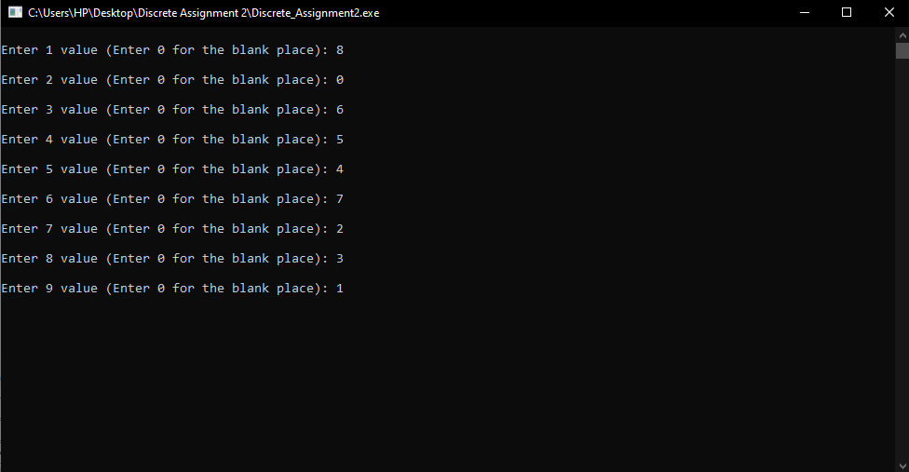

The program then computes and shows all the moves to get to the goal state. Now, this is a greedy algorithm which means it will not give an optimal solution for every puzzle, but it works fine.

